

Welcome Developers!

We’ve been hard at work to create a littleBits Hardware Development Kit that empowers engineers, designers, hackers, and makers to create their very own modules.  We are unleashing the power of littleBits to all of the great thinkers who have helped grow our community to see what great ideas they can add to our robust library.

Here’s a quick snapshot of the electrical requirements for designing your own modules:

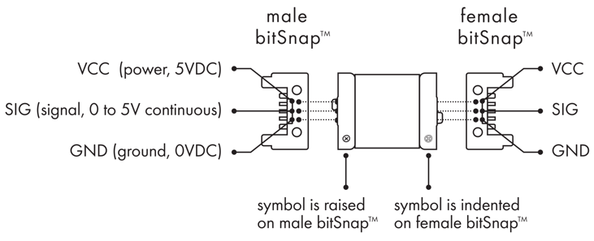

In order to submit a module for vote all you need to do is create a working prototype and document it.  As long as you can show it works, it doesn’t matter if it’s a PCB, a solderless breadboard, or anything in between.  If your module reaches 1,000 votes, you can then start exploring some of the additional documentation requirements highlighted below.

We’ve built out a number of libraries and reference documents to take out a lot of the guess work when exploring how to leverage the power of littleBits and your own creativity.  Make sure to explore our Eagle **parts libraries, design templates**, and **full and complete project example** in the HDK.

Along with your design we want to see your ideas in writing!  Fill out the Product Design Requirements (PRD) document that will help give some added insight into your goals, design process, and bit details.

We have added a ton of information to our support page so please check out [the FAQs](https://support.littlebits.cc/hc/en-us/categories/200126943-About-littleBits) if you’re interested in learning more.

We can’t wait to see your submissions!

The littleBits Team